**PowerBI Sales Insights Data Analysis Project**

**Phase-I: Recognizing the problem Statement**

XYZ is the owner of a company. The company is working in different regions of the country like north, south, central etc. The owner is facing hard time to make certain decisions because he doesn’t has proper sales insights.

The owner calls different regional managers and they convince him that sales are good and everything is fine. But the owner has notice some decline in sales but he has no idea what is happening and why is this happening because the managers give him verbal insights and try to convince him that things are going fine, when in reality they are not. When the owner asks for proper proof about the sales, the managers send him excel files containing hundred thousand records of sale and the owner cannot review those excel files.

The owner is so frustrated by all this and if the sales kept on decreasing the company may face extinction in near future. With all this frustration, one day he is at a get-together with his old college friends. One of his friend, ABC owns an IT company. XYZ consults his friend ABC on the matter of his company and how things been hard. ABC asks him to hire his IT Company for the data analysis. The way to visualize millions of records in form of graphs, charts to improve the understanding about how good or bad the company been doing and according to those insights the owner XYZ can take some proper actions to help increase company sales because when he gets to know what is actually causing the downfall of the company then he can act accordingly. Hence the problem statement is**, “Visualize all the sales data of company over the years in an orderly manner to help understand how well or bad the company has performed and from those insights what actions need to be taken.”**

**Aims Grid:**

1. **Purpose:**

To unlock sales insights that are not visible before for sales team for decision support and automate them to reduced manual time spent in data gathering.

1. **Stakeholders:**

* Sales Director.
* Marketing Team.
* Customer Service Team.
* Data Analytics Team.
* IT Team.

1. **End Result:**

An automated dashboard providing quick and latest sales insights in order to support data driven decision making.

1. **Success Criteria:**

* Dashboard(s) uncovering sales order insights with latest available data.
* Sales team able to take better decisions and prove 10% cost savings of total spend.
* Sale analyst stop gathering data manually in order to save 20% of their business, time and reinvest it value added activity.

**Phase-II: Solution Approach for given Problem Statement**

We have made three teams who will be contributing in order to complete this project. We will call them:

* Falcons.
* Data Miners.
* Data Masters.

**Falcons:**

The software engineers who are managing the sales management system and having access to database. They will provide database access to the Data Miners. This access will be granted on some certain rules defined by the stakeholders.

**Data Miners:**

The Data Engineers after getting the access from the Falcons, will create a new data warehouse where all the data from the database is copied and then shifted. This is done to make sure there is not a single impact on actual database while performing this project because if the data gets corrupted in main database then the whole company crashes due to unavailability of sales data. There for this is to make sure this never happens.

**Data Masters:**

The Data Analyst takes data from the data warehouse, clean it, make it smooth, polish it and then makes smooth, soothing and really interactive visualization dashboard. You can see the dashboard and you can know how well a company is doing.

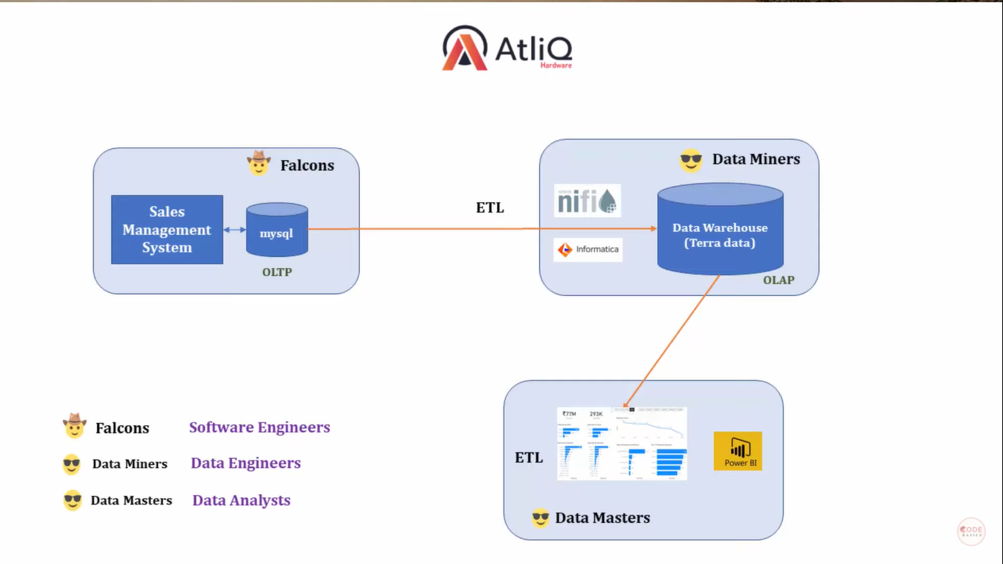

**PowerBI Report:**

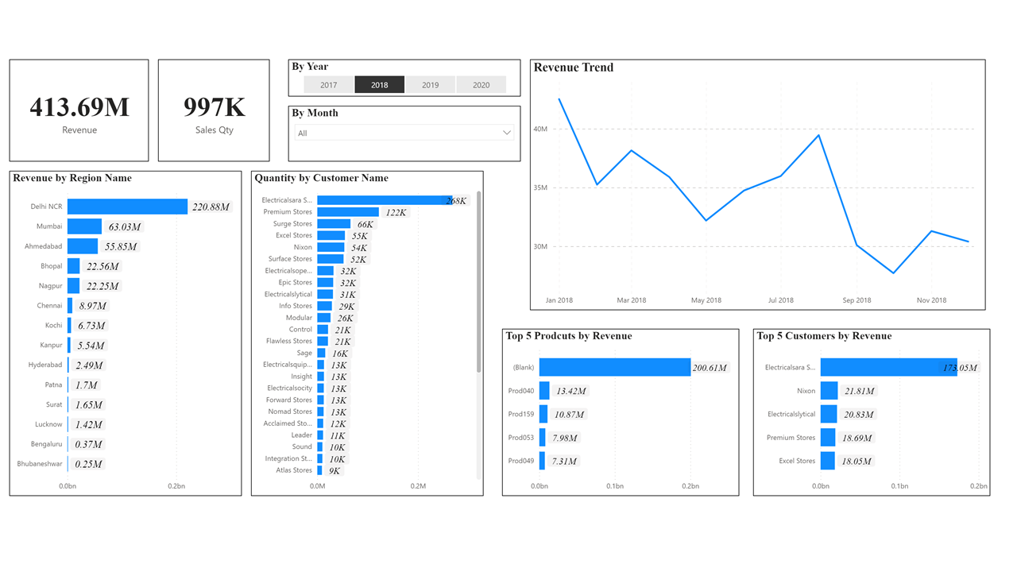After Complete data mining, cleaning and then analysis the dashboard for PowerBI is ready.